



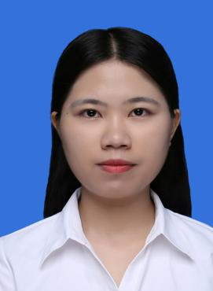
Where there is a will, there is a way.
Go for it.
Guide morning reading & English learning
Prepare lessons & teach grammar knowledge
2015/9-2016/6 Guangzhou College of Commerce Oral English Teacher
2017/7-2017/9 Guangzhou Bai Lin Trading Co., Ltd. Merchandiser Assistant
Follow up each order, communicate with customer through mail, telephone for daily affairs
Examine shipping documents, collect payments
2016/7-2016/8 Volunteer Center English Volunteer Teacher
Teach oral English with daily topics
Do simulation

Translation consultant for Fuzhou Jiebo Arts & Crafts Co. Ltd.
Quote for foreign customers, explain product usage and performance, record relevant information

谭一心
- English: TEM-4 (good/78), CET-4 (587), CET-6 (564), BEC Vantage (Grade C Level B2/170)➢
- Computer: MS Offices(Level 1), Photoshop（Level 2）

- Polite, sincere, helpful, optimistic
- Patient & concentrated, have a strong sense of responsibility, learning ability & adaptability
- Love sports & taking part in volunteering activities
Professional Skills
Summary
2017/10/23-27 Canton Fair Booth Translator
Job Objective: Foreign Trade Merchandiser
Date of Birth: 1995/12/14
Tel/WeChat: 159 8627 5343 Email: 1071785605@qq.com

2014/9-2018/6 Guangzhou College of Commerce Business English Bachelor of Arts
Working Experiences
Monitor of the learning classes in China ad hoc socialist Learning Society
Leader of the Activities-Planning Department in Fresh Environmental Protection Association
Awarded National Encouragement Scholarship/College Scholarship every academic year
Obtaining Excellent Team Leader/ Excellent Leader Prize
Education Background

